

NMEA Distribution Box
Eight RS422 and Two RS232 outputs NMEA Distribution Box
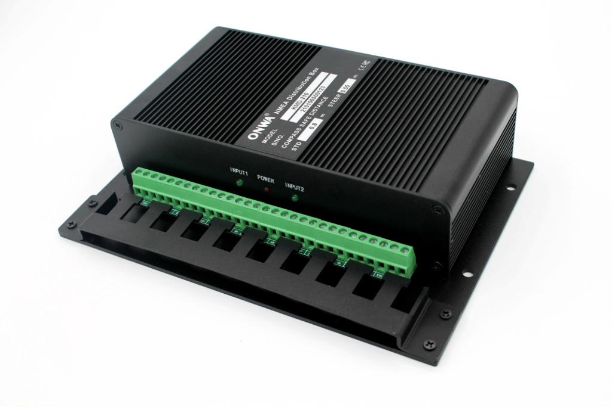
Model : KMD-210

- Power supply isolated
- Eight RS422 outputs and Two RS232 outputs (can be configure to Ten RS232 outputs)
- High speed baudrate up to 38400
- Input signal isolated
- Every channel output isolated
- Can be used as two independent NMEA distribution box

