

NMEA Distribution Box
Twelve RS422 and Three RS232 outputs NMEA Distribution Box
Model : KMD-550
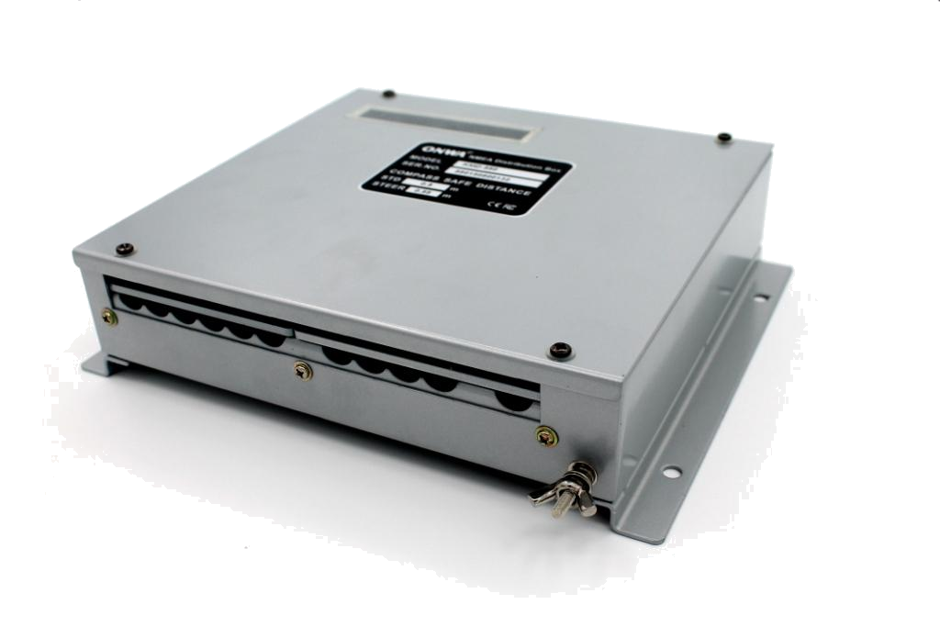

- Power Supply isolated
- Twelve RS422 outputs, three RS232 outputs and one speed closure signal (or Fifteen RS232 and one speed closure signal)
- High speed baudrate up to 38400
- Input signal isolated
- Every channel output isolated
- Can be used as two independent NMEA distribution box

